Fitness and Sports
Volleyball Unit
Game Overview
Volleyball is a high-energy sport played between two teams of six players. The object is to score points by hitting a ball over a net so that the opposition cannot return it before it hits the ground. Defensive players dive around the court to get their hands under the ball and push it up toward their teammates in attack, who are ready to leap high to smash it back over the net.
Rules and Regulations
- Choice of playing area or service at the start of a match is determined by the toss of a coin. After each game the teams alternate who serves first.
- The player in the right-back position makes the serve and continues as the server until side-out is called.
- When a team receives that ball for service, it rotates one position in a clockwise manner.
- Teams change courts when a game is completed.
- A return may be hit in any direction. A player may use any part of the body above the waist to hit the ball (below waist with intention is an infraction).
- After contacting the ball on a return, a player may not touch it again unless touched by another player.
- If any team commits an infraction, 1 point is awarded to the other team.
- Infractions include: serving illegally, failing to make a legal return, touching the ball twice in succession, contacting the net, touching the ball more than 3 times without passing over the net, reaching under the net, changing player positions prior to the serve.
- At the high school level a match consists of 2 out of 3 games to 25 points with the use of rally scoring. At the collegiate level a match consists of 3 out of 5 games to 25 points with a 5th game to 15 points.
Game Equipment
The Court-The playing area is usually made of wood or synthetic material-but the game can be played on any surface that does not cause injuries to diving players. Lines on the court show where players may stand at the start of each point: three defensers in the back zone (including the server, who starts anywhere behind the end line) and three attackers in the front zone close to the net.
The Net- The net is suspended across the court directly above the center line by two poles. The net is higher in men’s competitions than in women’s.
The Ball- Volleyballs should be inflated to a pressure that keeps them slightly soft, so that they have some “give.” They are then comfortable to play with using the hands.

Key Terms
Scoring- 25 points rally style. In rally scoring, a point is awarded on each play. Scoring team retains or gains the serve. Teams rotate positions after each side-out.
Serving- Method of initiating play. Only 1 serve attempt allowed. Serves can hit the net but must cross over. Blocking a serve is not allowed.
Faults- Violations that result in a loss of point and/or loss of the serve.
Game Format- Players set-up in rotational positions, without overlapping or moving until the serve is made.

Teams are allowed 3 hits maximum, a block does not count as a one of the team’s hits.
Basic Skills and Tactics
- Forearm Pass
- Set
- Spike
- Serve: Overhand
- Serve: Underhand
- Defense/ Offense
- Play calling

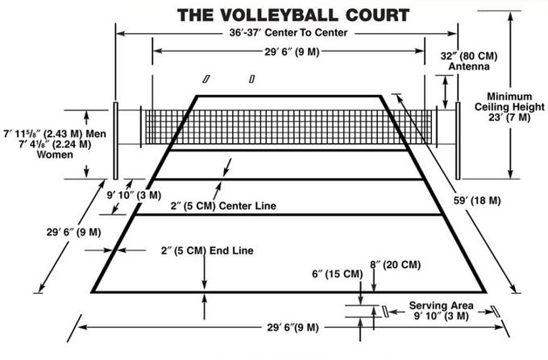
Class Applications
We will play best of 3 games to 15 points, win by 2, with a cap of 21.
Third and deciding games may need to be shortened depending upon time remaining.
Substitutions should always occur when a team receives a side out. The subs should help to keep score and then sub in as the server when awarded a side out.
All players must substitute equally and there should always be at least two females/males on the court at a time.
The ceiling and any object connected to it is considered out of bounds.
Everyone should work together to make all teammates successful and the game enjoyable.
The game should be played at a fast pace in order to allow enough time to complete the match during the class period.

