Fitness and Sports
Softball (Slow Pitch) Unit
Game Overview
Softball is a game in which two teams of nine players take turns at bat as they try to score the most runs around four bases laid out on a field of play. A game usually consists of 7 innings in which each team bats and fields 7 times. Softball is a striking/fielding game similar to baseball, cricket, rounders, and kickball.

Rules and Regulations
GAME REGULATIONS AND SCORING
- A coin toss determines the order of batting and fielding.
- A game consists of 7 innings, with equal teams of 10 players
- A run = 1 point. A run is earned for each offensive player who rounds the bases and crosses home without being tagged out.
- Outs are achieved by strikeouts, force-outs, tag-outs and fly-outs.
- Each team bats until 3 outs are recorded, at which point the inning ends.
PITCHING REGULATIONS
- Pitcher must rest facing the batter for at least 1 second, and release the ball within 10 seconds.
- 1 foot must remain in contact with the pitcher’s plate until the ball is released.
- Ball must be pitched underhand at a height of at least 6 feet and no more than 12 feet.
BATTING REGULATIONS
- Batter must remain in the batting area (batter’s box) while hitting.
- Batters must hit in the pre-determined batting order throughout the game.
- Batters cannot bunt (intentionally tapped ball meant to go a short distance).
- A strike is called for a swing and miss, foul ball, or a non-hit ball in a strike zone.
- A ball is called for an illegal pitch, or a ball not swung on and not in the strike zone.
BASERUNNING REGULATIONS
- Runners must touch bases in order. If missed, runner must re-touch bases in reverse order.
- Two baserunners may not occupy the same base at the same time.
- Runners cannot run more than 3 feet outside the baseline.
- Runners cannot pass another teammate when rounding the bases.
- No base stealing. A runner can leave base when a pitched ball reaches home or is hit.
Game Equipment
Softball -An 11 or 12 inch leather composite ball.
Bat- Most leagues require that a bat be no longer than 34 inches and weigh no more than 38 ounces.
Key Terms
BALL- A pitched ball not in the strike zone.
BASELINE- A direct path from base to base.
COUNT- The number of balls and strikes on a batter.
FOUL BALL- A ball landing outside the 1st and 3rd base sidelines.
INNING- Segment of game consisting of 3 outs per team.
STRIKE ZONE- Area between batter’s shoulders & knees.
WALK- A free on-base as a result of being pitched 4 balls.
Basic Skills and Tactics
- Throwing
- Catching
- Pitching
- Batting
- Fielding: Grounders/Flys
- Baserunning
- Decision Making

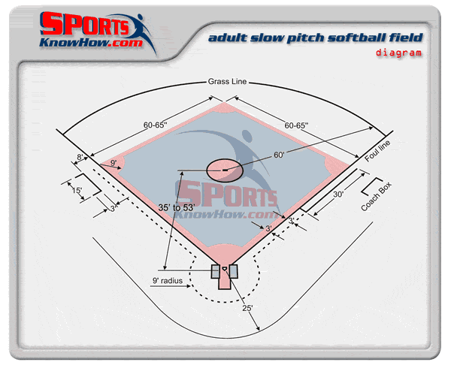
Class Applications
We will be outside playing slow pitch softball as much as posible but when forced to be inside, we will play wiffleball.

Wiffleball is an adaptation of baseball and/or softball that can be played almost anywhere.

The rules of Wiffleball allow for adaptations depending upon who and where the game is being played.

A Wiffleball can be pitched either over or underhand to the batter.

