Fitness and Sports
Soccer Unit
Game Overview
Widely considered the World’s most popular sport, soccer is played and watched by men and women in just about every country on Earth. Teams of 11 players consisting of forwards, midfielders, defenders and 1 goalkeeper compete against one another.
Rules and Regulations
- A game is divided into 2 45-minute halves timed with a running clock. Time lost to game stoppage (e.g. injuries or substitutions) can be added to the end of each half.
- One point is awarded for a ball that passes over the goal line into the goal.
- A coin toss determines the 1st possession. The team switch starting on defense gets the ball after half.
- Teams start in their own half of the field with the defense on the outside of the center circle. With the ball placed on the center mark, teams pass the ball forward to initiate play. They player making the 1st pass cannot handle the ball again until it has been touched by someone else.
- Players may only use their feet, head or chest to play the ball. The exceptions are the use of throw-ins to restart play and the goalkeeper position.
- A ball is out of bounds when it crosses the endline or sideline completely. A player may go out of bounds in order to keep a ball in play.
- Games ending in a tie are decided by extra time play, then penalty goal shootouts.
- Offside- Violation where an offensive player is closer to the opponent’s goal line than the ball.
  - Exceptions: 1) a player is in their own half of the field, 2) 2 opponents are closer to their own goal line, and 3) the ball is last touched by a defensive player.
- Free Kick- The result of a foul or misconduct. The 2 types of free kicks are direct and indirect.
  - Direct: a kick that can score without touching another player; for serious personal fouls.

  - Indirect: a kick that must be touched by another player before scoring; for technical fouls.

- Goalkeeper- May touch the ball with the hands/arms when inside the penalty box area.
  - Making contact or interfering with the goalkeeper in the goal box is prohibited.

Key Terms
Throw-in- A restart from sideline using 2 hands overhead
Corner Kick- A restart when ball crosses endline off the defense
Obstruction- Using body to shield player from ball
Goal Kick- A restart when ball crosses endline off the offense
Marking- Playing defense on an opposing player
Tackling- Taking ball from the offense with feet

Basic Skills & Tactics
- Dribbling
- Passing
- Trapping
- Shooting
- Give and Go
- Team Offense
- Defense- Mark & Zone

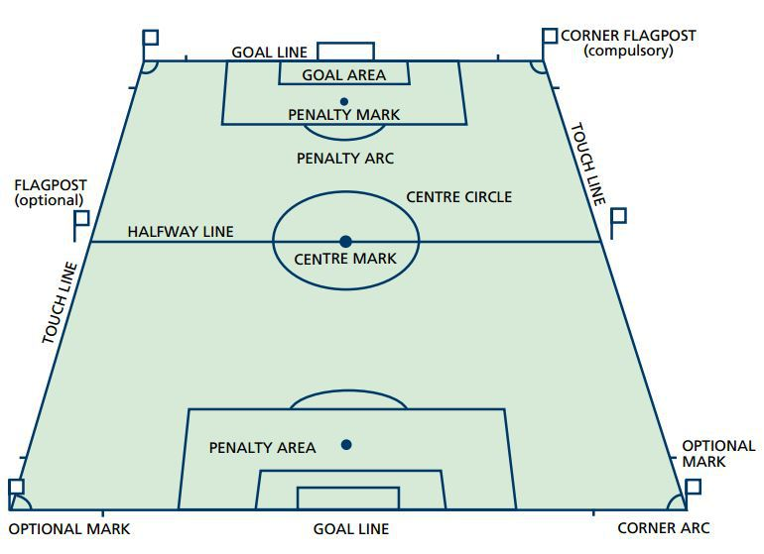
Class applications
The goalkeeper is not allowed to score and is considered only a defensive player. Each team must have a goalkeeper at all times of the game.
The goalkeeper can use any part of their body to stop a shot on goal. They can also throw or kick the ball to a teammate, but the ball must contact the ground prior to the halfway line.
Teams should rotate who the goalkeeper is and not allow one person to play the position all game, every game.

