Fitness and Sports
Hockey Unit
Game Overview
Ice hockey, or just “hockey” as it’s known in the United States and Canada, is a fast-paced, action-packed sport played on ice. During 60 minutes of regular time, split into three 20-minute periods, each team of six padded players tries to score by shooting a vulcanized rubber puck into the opposition’s goal using their stick or by deflecting it off their skates. Ice hockey is a dynamic and exciting game to play and watch; it attracts huge television audiences and legions of fanatical supporters.
Rules and Regulations
- A game is divided into 3 20-minute periods.
- One point is awarded for a ball/puck that passes over the goal line into the goal. However, a goal cannot be scored from inside the goalie crease.
- A coin toss determines defending ends. Teams switch ends after each period.
- Play is initiated and restated with a face-off between 2 opposing players. All other players must be 10 feet away and on their defensive side.
- A face-off is used when: 1) a period starts, 2) a goal is scored, 3) a puck is frozen between players, 4) a puck leaves the playing area, 5) for a penalty or violation. Face off takes place at the center circle for period starts and following a goal. All other face offs take place at the nearest circle.
- The puck can be advanced by use of the stick or by kicking. It can only be hit with the stick to score.
- Games ending in a tie are decided by extra time play, then penalty goal shootouts.
- Violations- the breach of rules resulting in penalty enforcement of time out of game.
  - Minor: a non-injurious personal foul such as kicking, tripping or high sticking (2 min.)
  - Major: a severe personal foul such as spearing, slashing or cross-checking (5 min.)
- Goalkeeper- May stop the puck with the body, hands, or stick when inside the crease area. Players may not contact or interfere with the goalkeeper in the goal crease.

Key Terms
Clear- Passing puck out of defensive end to prevent a score
Cross-check- Hitting an opponent with a sideways stick
Dribble- Moving the puck with both sides of stick
Face-off- An initiation or restart of play between 2 opposing players
High Stick- Raising the stick blade above waist
Power Play- Uneven teams due to a penalty

Basic Skills & Tactics
- Dribbling
- Passing
- Shooting
- Fielding
- Tackling
- Give and Go
- Team Offense
- Defense- Mark & Zone

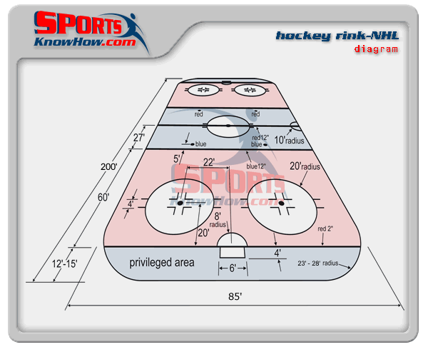
Class applications
The goalkeeper is not allowed to score and is considered only a defensive player. Each team must have a goalie at all times of the game.
The goalkeeper can use their hands to stop a shot on goal. They can also throw the puck to a teammate, but the puck must contact the ground prior to the mid-line.
The goalkeeper is the only player who is allowed in the “crease” which is the free throw lane lines and volleyball baseline. This includes the use of a hockey stick to retrieve a loose puck or rebound.
No “checking” of any kind is allowed and will be tolerated. Any form of checking will result in a penalty and a loss of points.
The puck is to never be lifted from the ground intentionally and passes should be short and controlled.
Any swinging of the stick above the waist is considered “high sticking” and will result in a penalty.
A puck may be caught with an open hand if it is in the air, but it must be immediately dropped and not thrown in any way to advance.

