Fitness and Sports
Ultimate Unit
Game Overview
Ultimate is a 7-a-side game in which teams float a plastic disc, known as a Frisbee, to teammates. A team scores a point every time one of them catches the disc inside the end zone that they are attacking. A thrower may pass the disc in any direction to a teammate. Ultimate is self-refereed and is a noncontact sport. The spirit of the game guides how players referee the game and how the players conduct themselves.

Rules and Regulations
- Player positions- Handlers (precise throwers), Mids (quick cutters), and Longs (fast receivers).
- Beginning Play- Teams line up across the front of their endzone. Play begins with a “Pull.”
- Moving the disc- Offense moves the disc by completing passes. Players cannot run with the disc. One defender is allowed to guard the handler, all others must be at least 10 feet away.
- Scoring- 1 point is awarded for catching a pass in the opposing team’s endzone.
- Stall Count- The disc handler has 10 seconds to throw. Defender guarding the handler counts the time.
- Turnovers- The defense takes possession and becomes the offense when the disc goes out of bounds, is dropped, blocked, intercepted, or a stall count occurs.
- Fouls- Any contact results in a foul. Picks and screens are not allowed. Defensive fouls result in a Re-Do, offensive fouls result in a turnover.
- Self-Officiating- Players call their own fouls and boundary violations. While no “Referees” exist, there are “Observers” who may be used to manage games.
- Spirit of The Game (SOTG)- Sportsmanship and fair play are the cornerstones of Ultimate. Competitive play is encouraged, but not at the expense of respect among players, following the rules, self-officiating, and the basic joy of play.

Game Equipment
Frisbee (Disc)-An 11 inch plastic floating disc. The name Frisbee is a brand that has been used to describe the disc played with in the game of Ultimate.

Key Terms
Brick Mark- A field marking used for restarting play.
Dump- Short pass used to reset the offense.
Flow- Fast and fluid offensive movement.
Huck- A long throw, generally for a score.
Pull- Long throw to begin play.

Basic Skills and Tactics
- Forehand Throw
- Backhand Throw
- Clap Catch
- “C” Catch
- Zone Offense
- Horizontal Stack Offense
- Zone Defense
- Force Defense

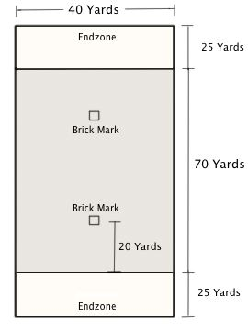
Class Applications
We will utilize a 5 second stall count for class purposes.

The wall and/or curtains are out of bounds and the disc cannot be caught off of them at any time.

Each game will begin with a disc flip to determine which team will “pull.”

Playing Ultimate the proper way should allow students to reach and remain in their target heart rate zone as well as improve their hand-eye coordination.

A Team must complete at least 3 passes before a score can be counted and both a female and a male must touch the disc.

