Fitness and Sports
Basketball Unit
Game Overview
Invented in the late 19th century, basketball is a fast-paced, highly technical ball sport, whereby two teams of five players attempt to score points in the opposing side’s basket. Most popular in the United States, where the National Basketball Association (NBA) runs the professional game, it also has a strong presence in Europe. Basketball has been an Olympic sport since 1976.
Rules and Regulations
- A game is divided into 4 8-minutee quarters.
- A Field Goal (basket) is worth 2 points from inside the 3-point arc, 3 points from behind the 3-point arc, and 1 point if made during a penalty with free throw shot. The ball must travel completely through the hoop to score.
- Play is initiated with a jump-ball between 2 opposing players. All other players must be outside the center circle. Possession alternates each quarter for the rest of the game.
- Possession changes within a quarter each time a basket is made.
- An offensive player cannot remain in the free throw lane for longer than 3 sec.
- A ball that goes out-of-bounds is awarded the opposite team of who touched it last.
- To move with the ball, a player must dribble with 1 hand at a time.
- An offensive player may take 2 steps while in possession of ball without dribbling.
- Extra play is used to determine a winner, when a tie score occurs at the end of a game.
- Violation- a breach of the rules resulting in loss of ball or shots from the free throw line.
- Personal: a non-injurious personal foul such as pushing, tripping or charging.
  - 1 Free throw if occurring during a shot attempt, and basket was made.
  - 2 Free Throws if occurring during a shot attempt, and basket was missed.
- Technical: a severe personal foul such as unsportsmanlike conduct. The player is awarded 2 free throws and possession of the ball after the penalty free throws.
Game Equipment
Basket-The modern basket is a metal-rimmed hoop, measuring 18 in across to a fixed backboard. The basket also contains netting which allows for a consistent drop of the ball.
Ball- The basketball is made from 8 finely stitched pieces of leather filled with air. The size and weight of the ball varies depending upon who is engaging in the game.
The beauty of basketball is that you can play almost anywhere with very little equipment need.
Tactics
While the object of the game is simple-to score more points than the opposing team-some of the strategies to achieve this can be increasingly complex as the standard of play rises. Offensive plays usually center around rapid counterattacks, using a variety of formations to get the ball up court as quickly as possible. Offense is often directed by the team’s point guard. Defensive plays require discipline tracking an opponent stride for stride and attempting to spoil their work.

Key Terms
Assist- A pass that directly leads to a score.
Charging- Contact with a defender by the ball handler
Fast Break- Moving the ball quickly to gain advantage
Fouled out- Ejection due to excessive fouls
Traveling- Taking > 2 steps with ball without dribbling
Weakside- Offensive side of court opposite the ball

Basic Skills and Tactics
- Dribbling
- Passing
- Shooting
- Give and Go
- Pick and Roll
- Team Offense
- Defense: P-2-P & Zone
The Court
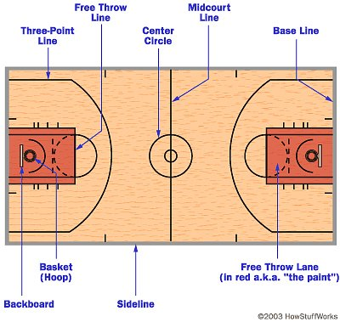

Class Applications
We will be participating in a half-court, 3-on-3 style of gameplay
Games will be played for a 10 minute time period (2 games per class period)
The ball must be cleared beyond the 3-point arc after every change of possession
Everyone should work together to make all teammates successful and the game enjoyable
All team members must touch the ball at least 1 time before a team can score a basket
Substitutions should be made after every made basket and an even rotation needs to be established
The game should be played at a fast pace in order for players to reach and stay in their target heart rate zones

