Arm Workout:
Standing Curl (15-12-8-8-12-15)
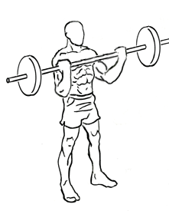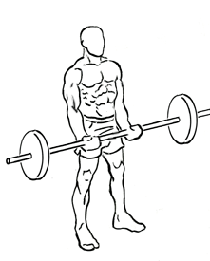
Tricep Extension (15-12-8-8) …Can sit while doing it.

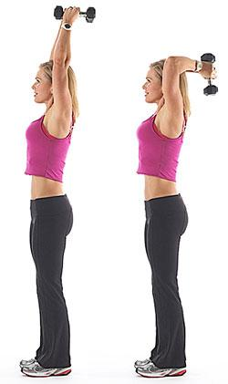
Wide Bar Curl (5 sets of 5 reps….no break)

Hammer Curl (15-12-8-8-12-15) ---Student sits and puts elbow on inside of leg---lift weight bending at elbow.
Tricep Kickback (15-12-8-8-12-15) – hold onto chair. Put elbow up. Push the weight back with keeping the elbow up and keeping it still.

BACK WORKOUT

Reverse grip row (15-12-8-8-12-15)
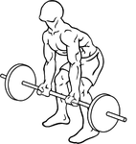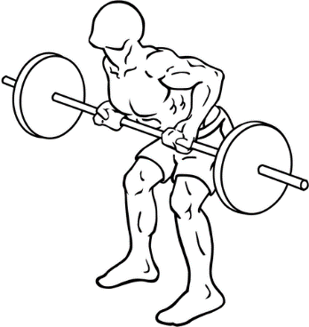

One Arm Row (5 sets of 5, no break)
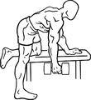
Deadlift (15-12-8-8) - student will bend down and come up and squeeze shoulders
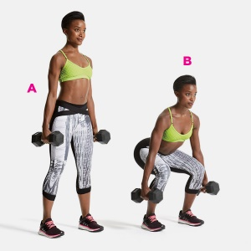
Reverse Fly (15-12)
